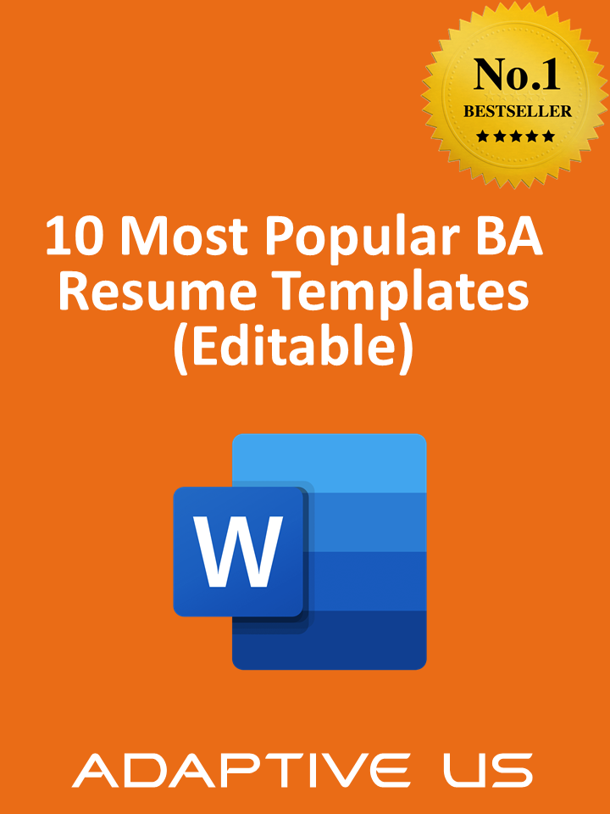

Specialist Resume (Delete this tag)
DANIELLA WALSH
YOUR JOB TITLE GOES HERE
CONTACT ME  Phone Number  name@email.com  Location, City ,State  www.yourwebsite.com  Twitter @username  EDUCATION  Degree Name  University Name,  Location, Graduation Year  Degree Name  University Name,  Location, Graduation Year  SKILLS  List all skills you have mastered throughout your career.  - Skill #1  - Skill #2  - Skill #3  - Skill #4  - Skill #5  - Skill #6 |  |  | PROFESSIONAL PROFILE  Write a concise, two sentence summary of your job history including: years of experience, industry of experience, and areas of experience. Include specifics about your areas of expertise and when you have had proven success.  Learn more at www.YourWebsite.com or follow me on Twitter @YourName.  WORK EXPERIENCE  WRITE YOUR JOB TITLE HERE  Company Name | Location | 2018 - present  In two or three sentences, provide an overview of your responsibilities in this position. What did you accomplish daily that led to proven overall success for the company as a whole?  - Here, write a one to two sentence synopsis of how you achieved success in your current position with a specific project you led or owned.  - One to two sentence synopsis of how you achieved success in your current position with a specific project you led or owned.  WRITE YOUR JOB TITLE HERE  Company Name | Location | 2014 - 2018  In two or three sentences, provide an overview of your responsibilities in this position. What did you accomplish daily that led to proven overall success for the company as a whole?  Here, write a one to two sentence synopsis of how you achieved success in your current position with a specific project you led or owned. One to two sentence synopsis of how you achieved success in your current position with a specific project you led or owned.  WRITE YOUR JOB TITLE HERE  Company Name | Location | 2012 - 2014  In two or three sentences, provide an overview of your responsibilities in this position. What did you accomplish daily that led to proven overall success for the company as a whole?  Here, write a one to two sentence synopsis of how you achieved success in your current position with a specific project you led or owned.  One to two sentence synopsis of how you achieved success in your current position with a specific project you led or owned.

Strategist Resume (Delete this tag)
CONTACT ME  Phone Number  name@email.com  City, State  www.yourwebsite.com  Twitter @username  LinkedIn.com/username  AREAS OF EXPERTISE  Experience Highlight  This is where you will mention  your experience more generally  Experience Highlight  This is where you will mention  your experience more generally  Experience Highlight  This is where you will mention  your experience more generally  AWARDS  Excellence Award  This is where you can write a blurb about an award  Excellence Award  This is where you can write a blurb about an award  . |  |  | JOHN B. CLARK  YOUR JOB TITLE GOES HERE  Write a concise, two sentence summary of your job history including: years of experience, industry of experience, and areas of experience. Include specifics about your areas of expertise and when you have had proven success.  WORK EXPERIENCE  WRITE YOUR JOB TITLE HERE  Company Name • Location • 2018 - Present  In two or three sentences, provide an overview of your responsibilities in this position. What did you accomplish daily that led to proven overall success for the company as a whole?  - Here, write a one to two sentence synopsis of how you achieved success in your current position with a specific project you led or owned.  - One to two sentence synopsis of how you achieved success in your current position with a specific project you led or owned.  WRITE YOUR JOB TITLE HERE  Company Name • Location • 2016 - 2018  In two or three sentences, provide an overview of your responsibilities in this position. What did you accomplish daily that led to proven overall success for the company as a whole?  - Here, write a one to two sentence synopsis of how you achieved success in your current position with a specific project you led or owned.  WRITE YOUR JOB TITLE HERE  Company Name • Location • 2014 - 2016  In two or three sentences, provide an overview of your responsibilities in this position. What did you accomplish daily that led to proven overall success for the company as a whole?  Here, write a one to two sentence synopsis of how you achieved success in your current position with a specific project you led or owned.  EDUCATION & CREDENTIALS  Degree Name  University Name, Location,  Graduation Year  Certifications: Include any and all certifications you hold.

Specialist Resume (Delete this tag)

Chris Walsh  POSITION TITLE | Write a concise, two sentence summary of your job history including: years of experience, industry of experience, and areas of experience. Include specifics about your areas of expertise and when you have had proven success.

CONTACT  Phone Number  name@email.com  Location, City ,State  yourwebsite.com  LinkedIn.com/username  Twitter @username  EDUCATION  Masters Degree  Major  University Name,  Graduation Year  Bachelor's Degree  Major  University Name,  Graduation Year  SKILLS  List all skills you have mastered throughout your career.  - Skill #1  - Skill #2  - Skill #3  - Skill #4  - Skill #5  - Skill #6 |  |  | WORK EXPERIENCE  Enter your job position here  COMPANY NAME | 2016 - 2017  In two or three sentences, provide an overview of your responsibilities in this position. What did you accomplish daily that led to proven overall success for the company as a whole?  - Here, write a one to two sentence synopsis of how you achieved success in your current position with a specific project you led or owned.  - One to two sentence synopsis of how you achieved success in your current position with a specific project you led or owned.  Enter your job position here  COMPANY NAME | 2016 - 2017  In two or three sentences, provide an overview of your responsibilities in this position. What did you accomplish daily that led to proven overall success for the company as a whole?  - Here, write a one to two sentence synopsis of how you achieved success in your current position with a specific project you led or owned.  - One to two sentence synopsis of how you achieved success in your current position with a specific project you led or owned.  Enter your job position here  COMPANY NAME | 2016 - 2017  In two or three sentences, provide an overview of your responsibilities in this position. What did you accomplish daily that led to proven overall success for the company as a whole?  - Here, write a one to two sentence synopsis of how you achieved success in your current position with a specific project you led or owned.  - One to two sentence synopsis of how you achieved success in your current position with a specific project you led or owned.

Nick Stevens  Intern Title | Phone Number  Location, City, State  name@email.com  Yourwebsite.com

OBJECTIVE
In a few sentences, summarize what makes you the standout intern in your field. Explain your qualifications in more detail, what you’re looking for to start your career and how you can contribute
to a new company.
SKILLS
This is where you will list all of the programs and software that you are familiar with using.

EXPERIENCE & PERSONAL PROJECTS  WRITE YOUR JOB TITLE HERE  Company Name • Location • 2018 - Present  In two or three sentences, explain your responsibilities in this role and how your success in this position led to proven overall success for the company. Whether this position is an internship, part-time, or full-time position, treat it with equal importance.  WRITE YOUR JOB TITLE HERE  Company Name • Location • 2018 - Present  In two or three sentences, explain your responsibilities in this role and how your success in this position led to proven overall success for the company. Whether this position is an internship, part-time, or full-time position, treat it with equal importance.  VOLUNTEER EXPERIENCE  WRITE YOUR JOB TITLE HERE  Company Name • Location • 2018 - Present  In two or three sentences, explain your responsibilities in this role and how your success in this position led to proven overall success for the company. Whether this position is an internship, part-time, or full-time position, treat it with equal importance. |  | EDUCATION  Degree Name  University Name  Expected graduation Date  Current GPA, #.#  A Campus Club you are a part of  An award you have received

Sue Chung
Some. One. Word. Personal. Descriptors.

About Me | In a few sentences, summarize what makes you the standout intern in your field. Explain your qualifications in more detail.
My Experience | Role Title  Company Name • Year  In two or three sentences, explain your responsibilities in this role and how your success in this position led to proven overall success for the company. Whether this position is an internship, part-time, or full-time position, treat it with equal importance.  - Go into more details about your daily responsibilities in this position.  - Mention any software, programs, or social media forms that you mastered using while in this position.  - Don’t forget to include any large projects you are proud of completing in this position.
My Education | Currently studying for a Your Degree at University Name  Expected graduation Month and Year  Current GPA, #.#  A Campus Club you are a part of,  Another Campus Club you are a part of
Learn More | Blog: www.YourBlog.com  Twitter: @YourName  LinkedIn: www.linkedin.com/in/YourName

Alex Carter  Position Title  Phone Number  Location  name@email.com  EDUCATION  Degree Title, University  GRADUATION YEAR, GPA  Latin Honors Earned  Include Scholarship  Did you study abroad?  Include that here..  TECHNICAL SKILLS  This is where you will list all of  the programs and software that you are familiar with using.  - List Item 1  - List Item 2  - List Item 3  - List Item 4  - List Item 5 | SUMMARY  Use this space to write a two or three sentence summary of who you are as a professional. Include that you are an entry level employee, and because you are entry level take this as an opportunity to mention who you are as an employee. Include whatever experience in your industry that you do have.  See my personal website and blog at www.YourWebsiteHere.com  EXPERIENCE  Your Job Title Here 2020 - PRESENT  Company Name, Location  Whether this position was an internship, part-time, or full-time position, it should be treated the same. This is where you write your responsibilities in this position and how your actions in your role led to overall success for the company.  Your Job Title Here 2020 - PRESENT  Company Name, Location  Whether this position was an internship, part-time, or full-time position, it should be treated the same. This is where you write your responsibilities in this position and how your actions in your role led to overall success for the company.  Your Job Title Here 2020 - PRESENT  Company Name, Location  Whether this position was an internship, part-time, or full-time position, it should be treated the same. This is where you write your responsibilities in this position and how your actions in your role led to overall success for the company.  FREELANCE WORK  Whether this position was an internship, part-time, or full-time position, it should be treated the same. This is where you write your responsibilities in this position and how your actions in your role led to overall success for the company.  - Include the base-line details of your freelancing work here. Include the industry you worked in, the size of your clients, and proven success you generated for them.

Hannah Burke  Position Title |  | Phone Number  Location, City, State  name@email.com  yourwebsite.com
EDUCATION  Degree Title, University  GRADUATION YEAR, GPA  Latin Honors Earned  Include Scholarship  Did you study abroad?  Include that here..  SKILLS  This is where you will list all of  the programs and software that you are familiar with using.  - List Item 1  - List Item 2  - List Item 3  - List Item 4  - List Item 5  AWARDS  2018 Excellence Award  This is where you can write a blurb about an award  2018 Excellence Award  This is where you can write a blurb about an award  2018 Excellence Award  This is where you can write a blurb about an award | SUMMARY  Use this space to write a two or three sentence summary of who you are as a professional. Include that you are an entry level employee, and because you are entry level take this as an opportunity to mention who you are as an employee. Include whatever experience in your industry that you do have.  See my personal website and blog at www.YourWebsiteHere.com  WORK HISTORY  Your Job Title Here 2020 - PRESENT  Company Name, Location  Whether this position was an internship, part-time, or full-time position, it should be treated the same. This is where you write your responsibilities in this position and how your actions in your role led to overall success for the company.  Your Job Title Here 2019 - 2020  Company Name, Location  Whether this position was an internship, part-time, or full-time position, it should be treated the same. This is where you write your responsibilities in this position and how your actions in your role led to overall success for the company.  Your Job Title Here 2016 - 2019  Company Name, Location  Whether this position was an internship, part-time, or full-time position, it should be treated the same. This is where you write your responsibilities in this position and how your actions in your role led to overall success for the company.

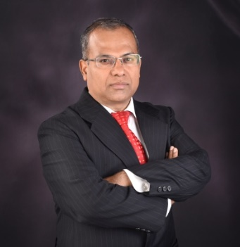 |  | LN@AdaptiveUS.com / +1 850 253 7200  Adaptive US Inc.  LinkedIn: LinkedIn.com/in/lnmishra

LN Mishra (LN) CBAP, CBDA, AAC, CCA

Helping BAs to Improve Their Careers: Guided 750+ BAs to be IIBA® Certified

World’s 1st BA to hold all 6 IIBA certifications

Practicing BA for 25+ years, Acclaimed Author, Versatile Trainer and Consultant

Co-founder and COO @ Adaptive US

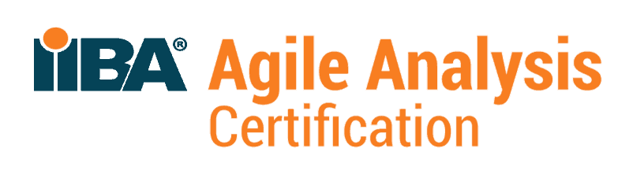  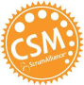  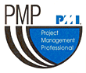  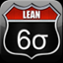 | I have 25+ years of professional experience in agile software development, requirements analysis, business analysis, IT GRC and management consulting.  I currently play the role of business analysis thought leader and product owner, SuXeed, Adaptive’s flagship learning solution. He has been part of multiple large system developments, In-country Value System for PDO Oman and Color Data Management System for AkzoNobel.  I was also involved in multiple large ERP implementation projects and was involved in one of the world’s largest change management program in PricewaterhouseCoopers, for a large utility agency.  I have conducted 300+ workshops in business analysis, requirements management, agile, software project management, Six Sigma, CMM, ISO 9001, and ISO 27001. I have guided 30+ six sigma projects in iGate, MACH and Akzo Nobel.  I hold Post Graduate Diploma in Management (PGDM) from IIM Ahmedabad, and BE (Honors) in Electronics.

Key competencies
Business analysis | Strategy formulation | Business process re-engineering | Software engineering
Requirements analysis | Stakeholder management | ERP implementation | Minitab
ERP Packages and Tools | Oracle Apps | UML modeling | Business process modeling (BizAgi)
MS-Office | Coaching, | Mentoring | Training

Books authored by LN | 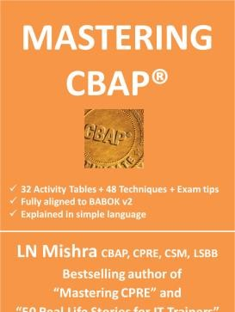 |  | 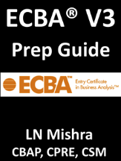 | 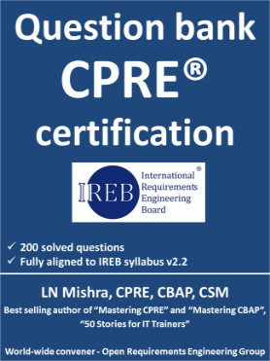
 |  | 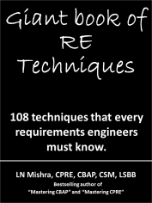 | 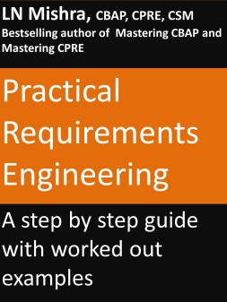 | 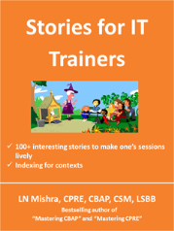
 | 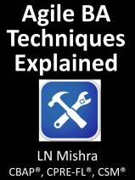 | 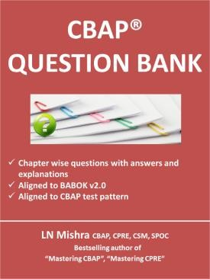 | 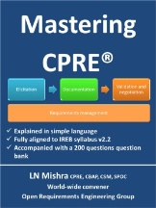 | 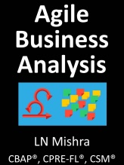
Academic Experiences
- MICA, Ahmedabad, 2019
- Designed and delivered a program on business consulting
- SOIL, New Delhi, 2018
- Designed and delivered a program on business analysis
- XIM, Bhubaneswar, 2017
- Designed and delivered a program on business process reengineering
- IIPM, Bangalore, 2001
- Designed and delivered a program on financial accounting
- AMC, Ahmedabad, 1996
- Designed and delivered a program on financial accounting

Detailed professional experiences
- Career Summary
- 25+ years of professional experience in software and consulting (software product development, business analysis, organizational change management, business process re-engineering), SW quality (CMMI, ISO 9001, Six-Sigma), information security (ISO 27001), IT service management (ISO 20000).
- Practicing business analyst for Fortune 100 client in paints and chemicals, and with Adaptive Processes for its Enterprise Governance, Risk and Compliance management system, GRCPerfect.
- Conducted 100+ workshops in US, India, Spain, Thailand in Agile, Scrum, Business Analysis and ISO series of standards.
- Published 15+ books on business analysis and requirements engineering.
- Certified Business Analysis Professional (CBAP) from IIBA, Canada.
- Certified Scrum Master from Good Agile, USA.
- World topper in Certified Software Quality Analyst (CSQA) from QAI, USA, 2000.
- Certified Project Management Professional (PMP) from PMI, USA,
- Consulted several clients in US, Europe, India including Toshiba, Nordstrom, iGate, Ness, MACH, Empower Research and Clutch Group.
- Personally steered 25+ clients for ISO 9001, ISO 27001 and ISO 20000 certifications.
- Designed and developed 25+ QMS, ISMS.
- Conducted 200+ training programs – both public and in-house on Business Analysis , Agile Project Management, Quality (CMMI, ISO, Six Sigma).
- Worked in multiple Oracle implementation projects in Financials, Inventory and Sales Compensation modules in Toshiba (US), Nordstrom (US), IKON Office Solutions (US), and Toshiba (Germany).
- Winner of Infosys Excellence Award.
- Academic Qualifications
- Post-Graduate Diploma in Management (PGDM), Indian Institute of Management, Ahmedabad, 1996.
- Bachelor’s in engineering (Electronics & Telecommunication) (Hons.), University College of Engineering, Burla, Orissa, 1992 (81 %).

- Achievements
- World’s #1 IIBA Certifications Trainer
- World Topper, Certified Quality Analyst Examination, 2000, QAI, USA
- Winner of Infosys Excellence Award for 2002
- 2nd Position in University in Electronics and Telecommunication Engineering, University College of Engineering, Orissa, India, 1992
- 3rd Position in Orissa, India, High School Certificate Examination, 1986.

- Professional Experiences
Business analyst, Principal Consultant and Trainer, Adaptive US, August 2017 onwards
Product Architect and Business Analyst – SuXeed – Adaptive BA Learning Solution
SuXeed is the most comprehensive BA learning system. It contains 100+ videos, 3000+ questions, 2000+ pages of BA content, audio books, flash cards, full length simulations for IIBA® certification examination. Has multiple categories of questions: Concept, Drill and Full-length simulations and has online Assessment System with similar features as IIBA® assessment system. Supports extensive reporting on assessment results and performance and deployed on Microsoft Azure cloud platform.
Product Architect and Business Analyst – GRCPerfect – Aug 2005 to April 2016
GRCPerfect is an Enterprise Governance, Risk, and Compliance Management System. It is designed to help companies implement Governance, Quality, and Information Security Management Systems in an integrated manner. It is extremely user-friendly, simple, easy to maintain yet very effective. It has pre-built processes for CMMI Level 5, ISO 27001, and ISO 9001. It is a complete data management system for CMMI Level 3, ISO 9001, and ISMS. GRCPerfect is live with more than 10 clients in India and US.
Business Analyst – Enterprise Data Management System, Leading Paint Manufacturer in the world, Feb 2011 to April 2016
I am helping the client in collecting requirements, responsible for collecting requirements for the new system, document requirements, and interface with software design and development team, test the solution developed.
ISO 20000 and ISO 27001 Implementation, Accel Frontline
ISO 9001 Implementation, Mindtree, Clutch Group
Head-PMO, Ness Technologies
ISO 27001 and ISO 9001 Implementation, Clutch Group
IBM Global Services India (IGSI), 2004 Apr – 2005 Jul
Manager – Software Quality Assurance
- Ensuring CMMI Level 5 compliance for Telecom accounts of IBM India
- Manage metrics and auditing projects to ensure compliance to client and organizational policies towards CMMI, ISO 9001 and ISO 27001
- Responsible for Customer Satisfaction (CSAT) process for IGSI for 300+ clients every half year
Infosys Technologies Limited, 1999 Aug – 2003 Sep
Oracle Financials Implementation, Toshiba Electronics, Germany
I was involved in implementation of Oracle Financials and Distribution modules, primary module being Oracle Receivables.

I was involved in user requirements analysis, fit gap, solution development, customisation, user training and acceptance. I

was also involved in project planning and estimation. This was a complete end-to-end implementation involving about 7 Oracle Applications modules and interfaces to several satellite systems.
Oracle Financials Implementation, Nordstrom, USA
I led the change management aspects of Oracle Financials implementation for Nordstrom. The project had fundamental implications for Nordstrom employees including its top management and impacted entire organisation as the financial reporting structure changed.
I was involved in strategy, planning and execution of the change management aspects. Primary focus areas were stakeholder expectation management, communication, skill building, team morale and ongoing support issues.
PricewaterhouseCoopers, India, 1997 Apr – 1999 Jun
Orissa State Electricity Board Privatization
The project was path breaking in its nature being the very first of electricity utility privatizations in India and had multiple stakeholders including utility supplier for one of the states in India, the state and central governments, World Bank, and Department for International Development, Govt. of UK, private investors and consumers. The project successfully transformed the utility from a loss making government concern to a professionally managed commercially viable private organisation.
I was responsible for interfacings with the top management of the utility agencies, workers union and consumer groups in a highly volatile and political environment. I was responsible for one of the project office operations including setting it up from scratch, equipping with requisite infrastructure and staffing. We as a team streamlined the revenue activities that yielded spectacular results. In one of the oldest distribution divisions, we improved energy-billed % by 20 % and collections over 30 %. In another division, we achieved an input to billing ratio of 70 % and collection efficiency greater than 90 %, which are comparable to some of the best-run utilities worldwide.
Ramco Systems, India, 1996 May – 1997 Mar
Business Development Manager
Centre for Development of Telematics (CDOT), 92 Aug to 94 Jun
Telecom R&D Engineer

NAME
Business Analyst
# Phone # _ Email ID

 bit.ly/LinkedIn-name
+ City, Country

EXPERIENCE

Business Analyst (Risk Management)

Scotiabank
~ 08/2018 - 08/2019 + Toronto, Canada
- Led the business analysis process for the Interest Rate Risk of the Banking Book project which increased project eﬃciency by 30%
- Provided cost/beneﬁt analysis and managed business expectations which reduced project cost of 20% with satisfactory result
- Engaged with business leaders, elicited the business rules into data logic and reduced any gaps within current capability by 20%
- Prepared data mapping and systems speciﬁcations documents and worked with the ETL developer reducing the development rework
- Led the design of the SQL test scripts for Hadoop Hive, veriﬁed the test results to identify gaps mitigating risks - reduced time and cost
- Developed strategies with the project team to increase the performance of data query process in the Enterprise Data Lake
- Worked with the Project Manager to ensure the project deliverables were delivered on-time and on-budget
- Provided training to DevOps team regarding the production stage, increasing the satisfaction level of end users

Data Scientist (internship)

WeCloudData
SUMMARY
An eﬀective team player looking to leverage 8+ years of experience as a Business Analyst. Successful at delivering quality business/system requirement documentation ahead of tight deadlines. Business process design and modelling, Waterfall and Agile project management, QA and end-user testing expertise. Well- versed and ﬂexible in implementing process assessments and redesigning for businesses of all sizes and adding value to the next organization.

SKILLS
Business Analysis
Process modeling BPMN User Stories

~ 12/2016 - 08/2018 + Toronto, Canada

- Worked on Data Science projects Uber Trip Data Visualization with Tableau and Financial Analysis with Yahoo API
- Generated reports and dashboards KPI’s which maximized data visualization with important business insights
- Predicted ﬁnancial trend using python data science workﬂow and techniques which increase data analysis accuracy and eﬃciency
- Prepared analysis result, report and presentation as course materials which increased 30% of students’ satisfactions

Business Analyst Lead

Ethacreation Inc.

Requirement engineering Use Case Diagrams
Data Flow Diagrams Visio Interpersonal and consultative Facilitation skills
Analytical thinking

~ 01/2013 - 12/2016 + Toronto, Canada

- Analyzed the business process to determine key elements for Salesforce CRM system which increased clients’ satisfactions
- Conducted conﬂict resolution to build cooperative client relationship which maximized clients’ satisfaction level
Project Management
Conﬂuence Jira MS Project SharePoint Waterfall Framework Agile Framework Scrum

EXPERIENCE
Business Analyst (External & Legal Entity Reports - EPM Implementation Program)
Royal Bank of Canada
SKILLS
Technical
Python SQL MySQL Oracle

~ 10/2012 - 01/2013
+ Toronto, Canada
Unix Windows Hadoop HDFS

- Collaborated with diverse stakeholders from Insurance, capital market, wealth management and international banking teams reducing communication gap
- Promoted the best business practices which enhance the ﬁnancial analysis process for end users reducing time and cost by 20%
- Collaborated with the developers to implement the data hierarchy
Hive Tableau Tableau Prep Talend IBM Infosphere IGC Collibra Tidal

design for Cognos TM1 cube lowering cost of development by 15%

Business Systems Analyst (Retail Investment)

Royal Bank of Canada
CERTIFICATION

~ 08/2008 - 01/2011 + Toronto, Canada

- Promoted the adoption of IBM WebSphere Portal system for RBC online banking increasing clients’ satisfaction by 30%
- Led JAD sessions and workshop to gather and assist the business

Certiﬁed Business Analysis Professional (CBAP)
IIBA - Expected to be certiﬁed in Feb 2022

leaders to prepare business cases and rules
- Developed System Requirements Speciﬁcations documents for

diﬀerent banking products reducing communication gaps
- Collaborated with CRA to gather the XML ﬁle requirements which

Certiﬁed Collibra Expert
Collibra Data Governance - Sept 2019

increased accuracy of TFSA client’s information to be sent annually
- Involved in all project phases and ensured all business requirements

were tested and implemented correctly which saved time and cost

Business Analyst

Omron Canada Inc.

The Master Certificate in Business Analysis
Schulich School of Business - June 2008
~ 10/2005 - 11/2007 + Toronto, Canada
- Collaborated with the Sales Manager, Marketing Manager, Customer Service Manager and Project Manager reducing communication gap
- Implemented the data migration speciﬁcations and led the SQL testing with the Data Analyst from Salesforce consulting services
- Implemented CRM system requirements with the Salesforce developer speeding up the sales analysis process increasing sales by 35%

EDUCATION

Master of Arts, Economics

York University
~ 2004 - 2005
- Major in Econometric and Operations Research

Honor Bachelor of Arts, Economics

York University
~ 2000 - 2004
- Major in Statistics and Finance

Name, CPRE-FL®, ECBATM®
Business Analyst, Adaptive Processes Consulting
Fathima Suhair is a practicing business analyst at Adaptive Processes. She has in-depth knowledge of business analysis practices, requirements modeling and UML. She has a keen acumen in the area of Business Analysis, Consultancy, Project Management, Scrum and Agile.
She is currently the BA for SuXeed, Adaptive’s Learning Management System. She also worked as a BA for GRCPerfect (Governance, Risk and Compliance product) developed by Adaptive Processes. She has also assisted in the review of books on Mastering CPRE, Guide to Requirements Engineering Body of Knowledge (REBOK) etc. authored by a veteran in Business Analysis domain, Mr. LN Mishra.
Throughout her professional career, she has maintained high standards of professionalism and integrity within a diverse range of different roles and have worked for organizations like Siemens LLC, Dubai, Al-Futtaim Engineering, Dubai and ITC InfoTech, Technopark, Kerala.
She has also helped organizations in implementing matured process and best practices. Some of her consultancy assignments include:
- NEC Retail Excellency Centre (NREC) – Assisted NREC in implementing ISO 9001:2008 and ISO 27001:2013 controls. Played the role of internal auditor assisting senior auditors in auditing varied processes and benchmarking them to industry best practices. Also playing the role of SQA and assisting the team to close the audit findings.
- NEC Technologies – Project Management related data mapping
- Harman International India Pvt. Ltd. – ISO 9001:2008 Re-certification

She has served as the Vice President (Public Relations) and Secretary of UAE Advanced Toastmasters and have also conducted training for the Toastmasters International’s (TMI) Club Officers. She has also won several accolades in communication and leadership roles like speaker, evaluator etc. as a member of the TMI, USA.
Fathima has published articles on Knowledge Management Systems, Building Automation and Mobile Marketing in a leading magazine called Executive Knowledge Lines and her technical papers on Power Quality Issues, Smart Grids etc. have won several accolades in college competitions. She has served as a volunteer for Teachers training for an NGO called Vakkom Moulavi Foundation Trust and is currently assisting in the process of developing a Media Centre for the same organization. Her other interests include art and craft works, henna designing, calligraphy, photography etc.
She holds a degree in Bachelor of Engineering (Honours) in Electrical and Electronics from Birla Institute of Technology, Pilani, Dubai Campus, one of India’s leading institutions exclusively dedicated to engineering education. She is currently pursuing her MBA in Consultancy Management from Bits Pilani.
Major Awards/Recognitions:
- Competent Communicator Award, Toastmasters International (TMI), USA
- Competent Leader Award, Toastmasters International (TMI), USA
- Advanced Leader Bronze, Toastmasters International (TMI), USA

- School Topper and UAE topper in SSLC-2005 examination. Awarded Gold medal by Indira Gandhi Veekshanam Forum, Abu Dhabi, All Kerala College Alumni Forum and NORPA
- School Topper in Higher Secondary Examination in 2007- Awarded Gold medal by Indira Gandhi Veekshanam Forum, Abu Dhabi and NORPA
- Winner of Merit scholarship from BITS Pilani, Dubai Campus in the years 2007, 2009, 2010 and 2011

